**PUBLIC TRANSPORTATION OPTIMIZATION USING MACHINE LEARNING**

**Team members**

622621121048: SATHIYAVATHI.S

Phase-1 Submission document

PROJECT:**PUBLICTRANSPORTATIONOPTIMIZATION**

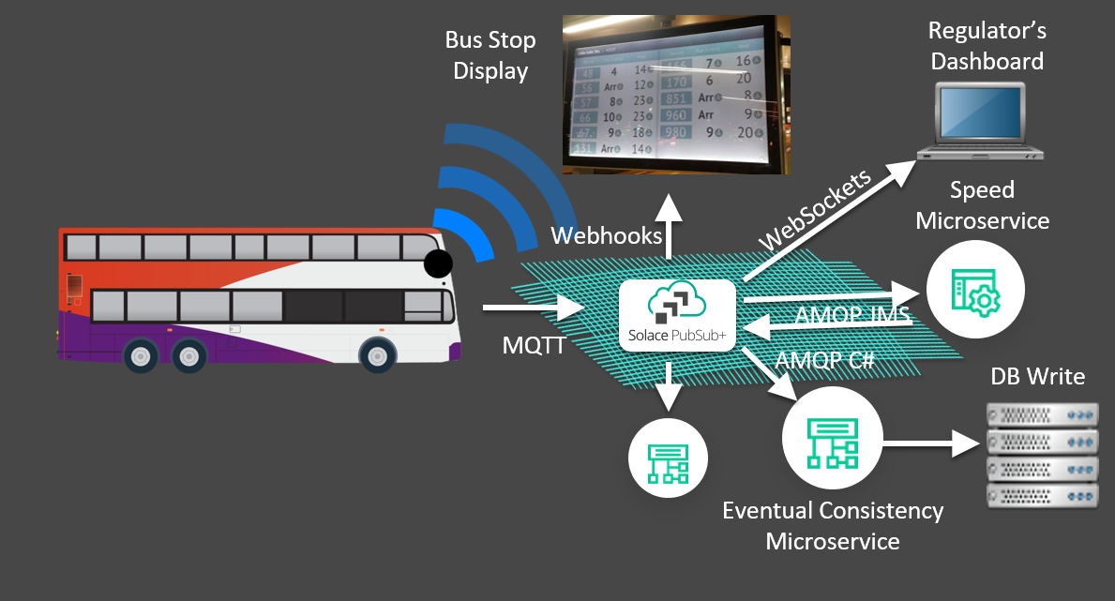

Public Transportation refers to a system of transportation services that are available for use by the general public, typically involving vehicles such as buses, trains, trams, subways, and ferries. These services are usually operated by government or private entities and are intended to provide an efficient and affordable way for people to move around within urban or regional areas.

Optimization in the context of public transportation refers to the process of making the system more efficient and cost-effective. This can involve various strategies, such as improving route planning, scheduling, and resource allocation to minimize costs, reduce travel times, and enhance the overall quality of service. Optimization can also consider factors like environmental sustainability and passenger convenience to create a well-balanced public transportation system that meets the needs of the community it serves.

Abstract

Public transport (also known as public transportation, public transit, mass transit, or simply transit) is a system of transport for passengers by group travel systems available for use by the general public unlike private transport, typically managed on a schedule, operated on established routes, and that charge a posted fee for each trip.

Coding of public transportation Optimization

Optimizing public transportation involves complex algorithms and software development. Here's a simplified overview of how you might approach coding aspects of public transportation optimization.

{

"id": [10000, 1],

"startNodeId": [1000, 0],

"endNodeId": [1001, 0],

"geom": { "points": [

{"lat": 37.7, "lon": -122.4},

{"lat": 37.8, "lon": -122.5}

]},

"length": 12,

"speedLimit": 11.2,

"lanes": 1,

"hmm": [

{"mode": "go", "mean": 1.2, "cov": 1.5, "prob": 0.85},

{"mode": "stop", "mean": 7, "cov": 0.1, "prob": 1.5E-1}

]

}

Here's an example of what one can get in 15 seconds on my machine. The code runs in two phases:

As time increases, the optimal policy is computed for reachable roads farther and farther from the destination (highlighted), until the source is reached.

Roads that can never be used to reach the destination on time are not examined.

Once the policy is determined, the optimal path for each time budget up to the one requested is determined, in order from high to low time budget.

This is to demonstrate the fact that the optimal path can change depending on the time budget.

THANK YOU